# CHAPTER FOUR

4.1 DESIGN AND IMPLEMENTATION OF THE SYSTEM.

This chapter is concern about the how the system was designed and how it will be implemented. System design is the process of defining the architecture, modules, interfaces, and data for a system to satisfy specified requirements. This could be seen as the theory behind the system to be built. System implementation (i.e. physical system building) on the other hand is the process of building the system and making sure the system is operational and meets quality standards as specified.

## 4.2 SPECIFICATION ANALYSIS.

This is a critical step to ensure the success of the development of the system. Here we take into consideration the system on which the final project will be ran and the system to use in the development of the project.

This project is built to run on systems with the following specification:

### 4.2.1 HARDWARE REQUIREMENTS.

* 512MB of minimum RAM
* 10GB of minimum Hard Disk Capacity

### 4.2.2 SOFTWARE REQUIREMENT.

* Windows operating system (Win2000, WinXP, WinVista or above)
* PHP server. Eg (XAMPP SERVER Setup)
* MySQL setup eg (XAMPP SERVER Setup)
* Web browser (Google Chrome, Mozila Firefox, Opera, Microsoft Edge, etc )

## 4.3 DATABASE DESIGN.

A database is an organized collection of data, generally stored and accessed electronically from a computer system. To create and use databases in the project, a Relational Database management system was used. A Database management system therefore is the tools that helps in creating and managing data stored in the database. Some of the basic operations provided by database management systems are create (inserting data to the database) , read ( retrieving data from the database), update ( updating data in the database) and delete (deleting unwanted data from the database).

Some of the benefits derived from using database management system to the project are as follows;

* Improved data sharing
* Improved data security
* Better data integration
* Better data storage
* Better data management
* Minimized data inconsistency
* Improved ease of data access
* Improved decision making

Sample database;

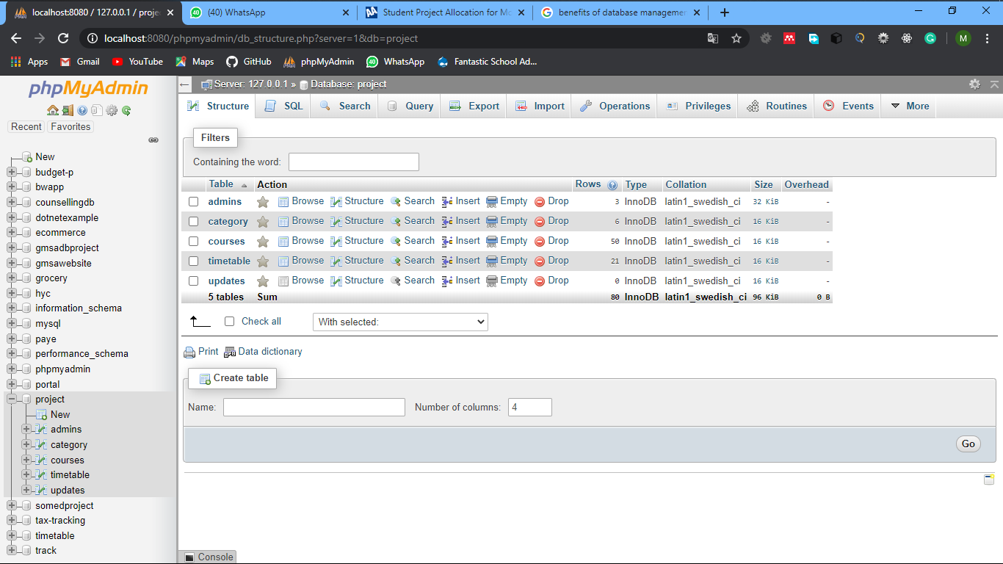

The above figure is the database structure of the project. It consists of 5 tables.

* The admin table stores the data of the administrator(s) of the project
* the category table stores information about the various department,
* the courses offered and the levels associated to each programmed offered,
* the course table store data about the courses offered in University for development studies
* the timetable table stores data about the current trimester timetable
* updates table store information about changes that has happened on the timetable and when it happens

## 4.4 SYSTEM SCOPE.